Press release ifm-pm 862/0526
Area: IIoT

AS-i now speaks moneo
Essen, 02. May 2026 – With the introduction of the moneo-compatible AS‑i master, ifm now enables sensors using the widely adopted AS‑Interface to benefit from the full functionality of the moneo IIoT platform. It allows AS-i data to be displayed, linked and processed in the dashboard. As users would expect from moneo, the data is available for condition monitoring, alarm management and further in-depth analysis.
A range of application scenarios highlights the added value that the combination of AS‑i and moneo offers to industry as well as operators of critical infrastructure: In the food industry, for example, the closing times of hygienic valves can be monitored continuously. AS‑i emergency stop chains in manufacturing environments can be safeguarded by combining safe AS‑i controllers with the moneo dashboard. Further examples include monitoring photoelectric sensors along conveyor systems or supervising valve positions in water treatment plants.
Even prior to integration, the ifm AS‑i master family featured a dedicated IIoT port that simplifies connection to the moneo IIoT platform. The inputs and outputs of the AS‑i master can be displayed as instruments on the dashboard, trigger alarms and send notifications via email or directly to mobile devices. They can also be logically linked, analysed in time charts, or stored in the long-term data archive.
This new addition to the moneo portfolio expands the range of already integrated components – such as IO‑Link masters, mioty base stations and VSE vibration monitoring modules – by incorporating another widely used fieldbus system that has been globally standardised for decades and is deployed in countless projects.
AS‑i sensors are wired using the patented flat cable piercing technology. With this quick-wiring method, each device is equipped with two contact blades (known as “vampires”) that establish contact with the two-core bus cable. This technology allows devices to be connected in just a few seconds without the use of tools. For users, this significantly reduces installation time and effort compared to conventional terminal wiring. Data and power are transmitted via the yellow AS‑i cable. The direct connection to the control network is realised via standard fieldbus systems (including PROFINET, Modbus, EtherCAT and EtherNet/IP) – optionally with functional safety up to PL e or SIL 3. By integrating AS‑Interface into the moneo ecosystem, ifm has created a seamless and comprehensive data connectivity solution that includes both IO‑Link and AS‑i.

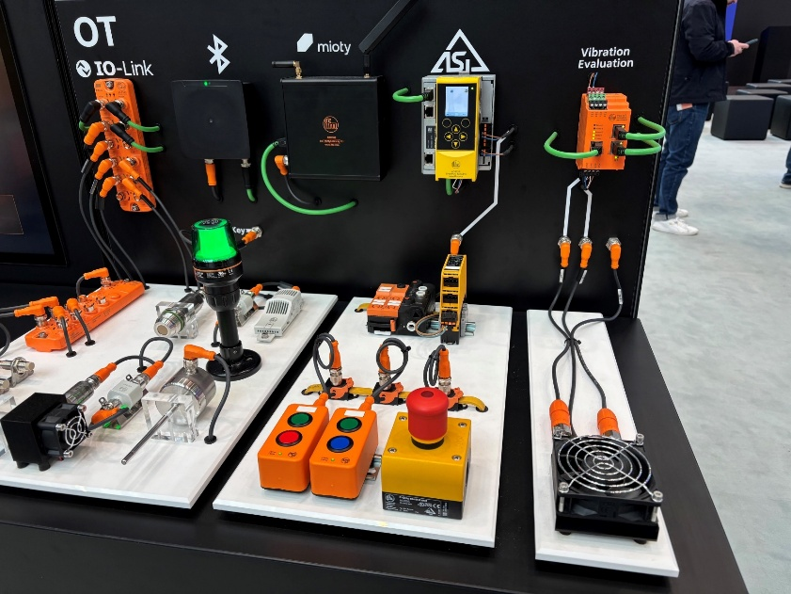 | ifm-pm 862 print.jpg  Step by step towards the connected factory: moneo integrates AS‑i masters. The edge gateway enables seamless connectivity between IT and fieldbus environments.

About the ifm group of companies

From a passion, to an idea, to success. Since its foundation in 1969, ifm has developed, produced and sold sensors, controllers, software and systems for industrial automation and for SAP-based solutions for supply chain management and shop floor integration worldwide. As one of the pioneers of Industry 4.0, ifm develops and implements consistent solutions to digitalise the entire value chain “from sensor to ERP”. Today, the second-generation family-run ifm group has more than 9,120 employees, including more than 5,260 in Germany, and is one of the worldwide market leaders. The group combines the internationality and innovative strength of a growing group of companies with the flexibility and close customer contact of a medium-sized company.

Printing free of charge – reference copy requested.

Editorial enquiries  Agentur Dr. Lantzsch  Jörg Lantzsch  Müllerstr. 5  65183 Wiesbaden  www.drlantzsch.de  Tel.: +49 611 205 93 71  Email: info@drlantzsch.de | Contact  ifm electronic gmbh  Simone Felderhoff  Friedrichstr. 1  45128 Essen  www.ifm.com  Tel.: +49 201 24 22 0  Fax: +49 201 24 22 1200  Email: presse@ifm.com

